**Replace Specializing Composition With Inheritance**

|  |  |  |
| --- | --- | --- |
| *a class specializes the behavior of its associated server* |  | *specialize the servers behavior using inheritance* |

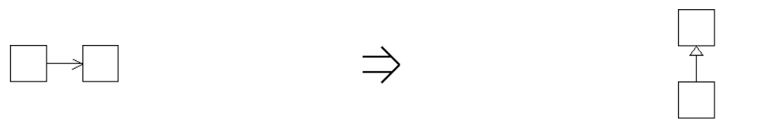

**Context:**

See also :[Replace Implementation Inheritance With Composition](https://web.archive.org/web/20090914101215/http:/www.refactoring.be/thumbnails/rtn-riiwc.html),*Replace Inheritance With Delegation[Fowler]*